# Portfolio Planning

**Finish Building Home Page:**

* X - Finish Base Layout Content Placeholders (no internal stuff, just design/placeholder blocks)
* X - Refactor homepage tags to use sections instead of divs everywhere.
* X - Refactor “Skills” 3-column layout to responsive.
* X - Structure Read Blog section with placeholder.
* X - Build “Start a project section”
* X - Build Footer with social icons
* Edit/Export assets needed for home-page portfolio items.
* Create placeholder pages for portfolio items…can be super bare bones for now
* Create ProjectCard component and interactivity.
* Build Work section using Project card components.
* Write Content for “Skills” 3-column layout.
* Finalize Design of “Skills” 3-column layout.
* Extract Images for Conference Presentations.
* Create placeholder pages for conference presentations.
* Reuse Project Card component to add conference presentations.
* Adjust classes for small screen better layout.
* Refactor – Add UI top Clouds
* Refactor – Add Nick Illustration Icons, convert to NickIllustration component
* Refactor – Adjust NickIllustration component to have some sizzle
* Refactor – Adjust the top nav colors based on page scroll (better if it automatically does it based on the section the user is scrolled to.
* Check code output and next/link to see if you need to use forwardHref on links for SEO (especially in top nav with custom wrapper component)
* Create overall blog & portfolio placeholder pages
* Refactor – Top Nav, make About scroll to that section, Blog & portfolio link to those placeholder pages.  
  Refactor – Break Home Page into components (HomePageHeader, etc)
* Refactor to use external file to load projects into home page (JSON file).
* Add Glasses favicon
* Push to github, test on mobile, make fixes

­

# Mood Board

# 

**Home page content very similar to this:**

https://mattfarley.ca/

# Home Page

**Custom Logo   
TODO: CREATE**



**Short Title & Byline in a hero-is component  
TODO: WRITE  
TODO: DESIGN**

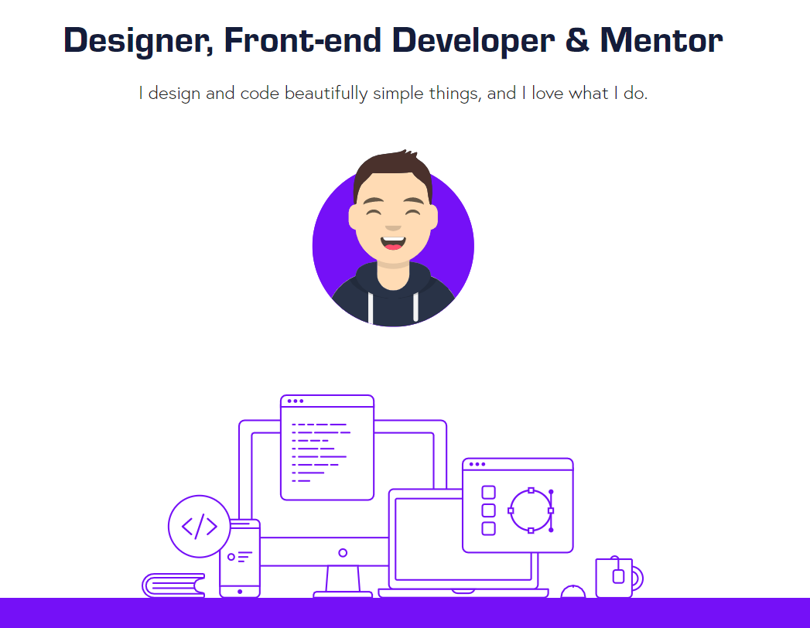

**More detailed description**

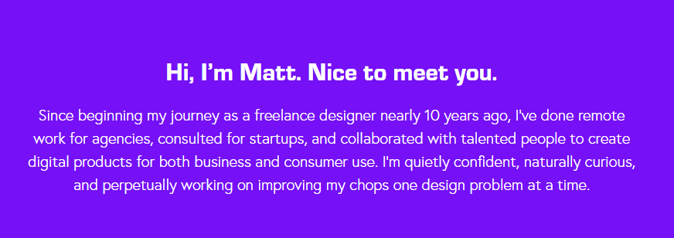

**High level skills breakdown**

**TODO: WRITE  
TODO: DESIGN**

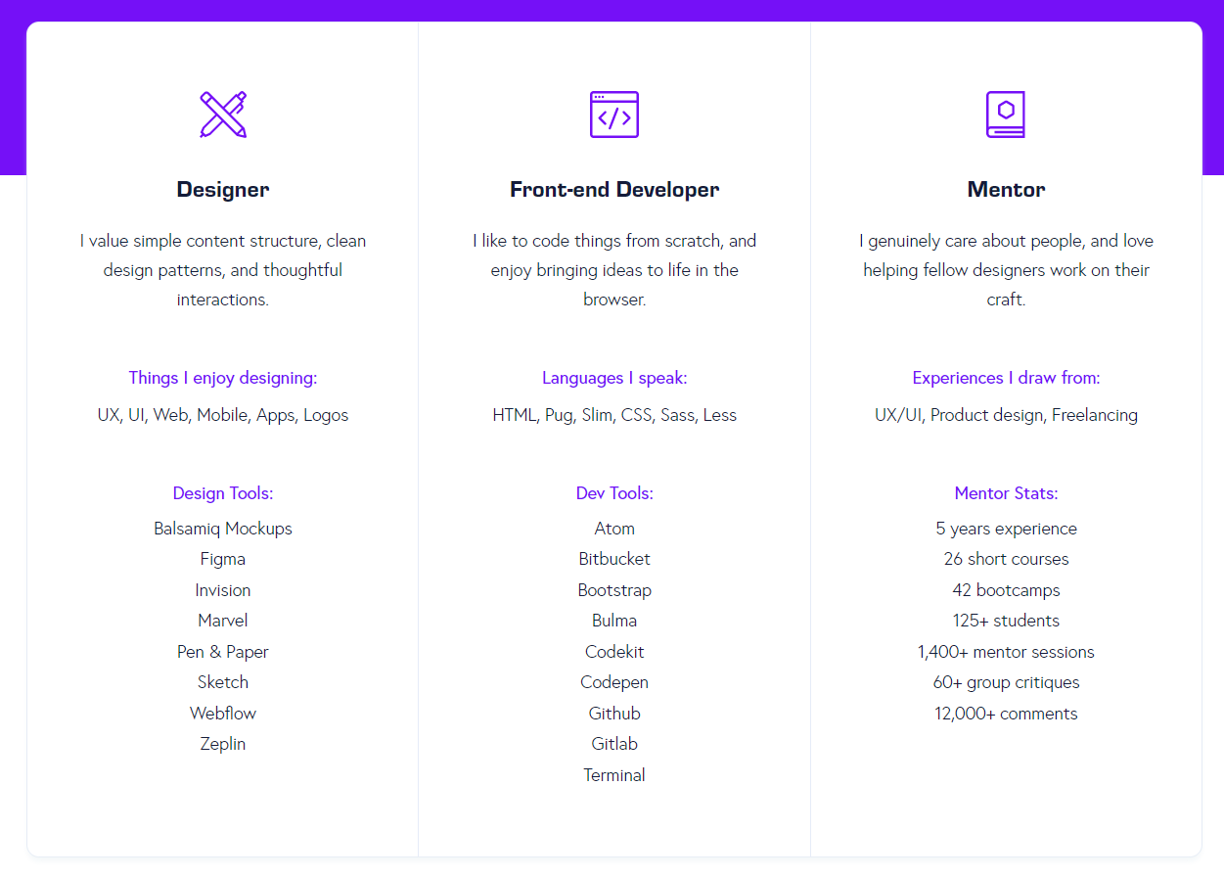

**Portfolio Snippet** (plus see more link)

**TODO: PICK 6**

* **Dormakaba**
* **Lilly**
* **Charter/Spectrum**
* **eMag**
* **AELH**
* **UFC App (in development)**

**TODO: DESIGN CARDS  
TODO: WRITE/DESIGN HOVER EFFECT**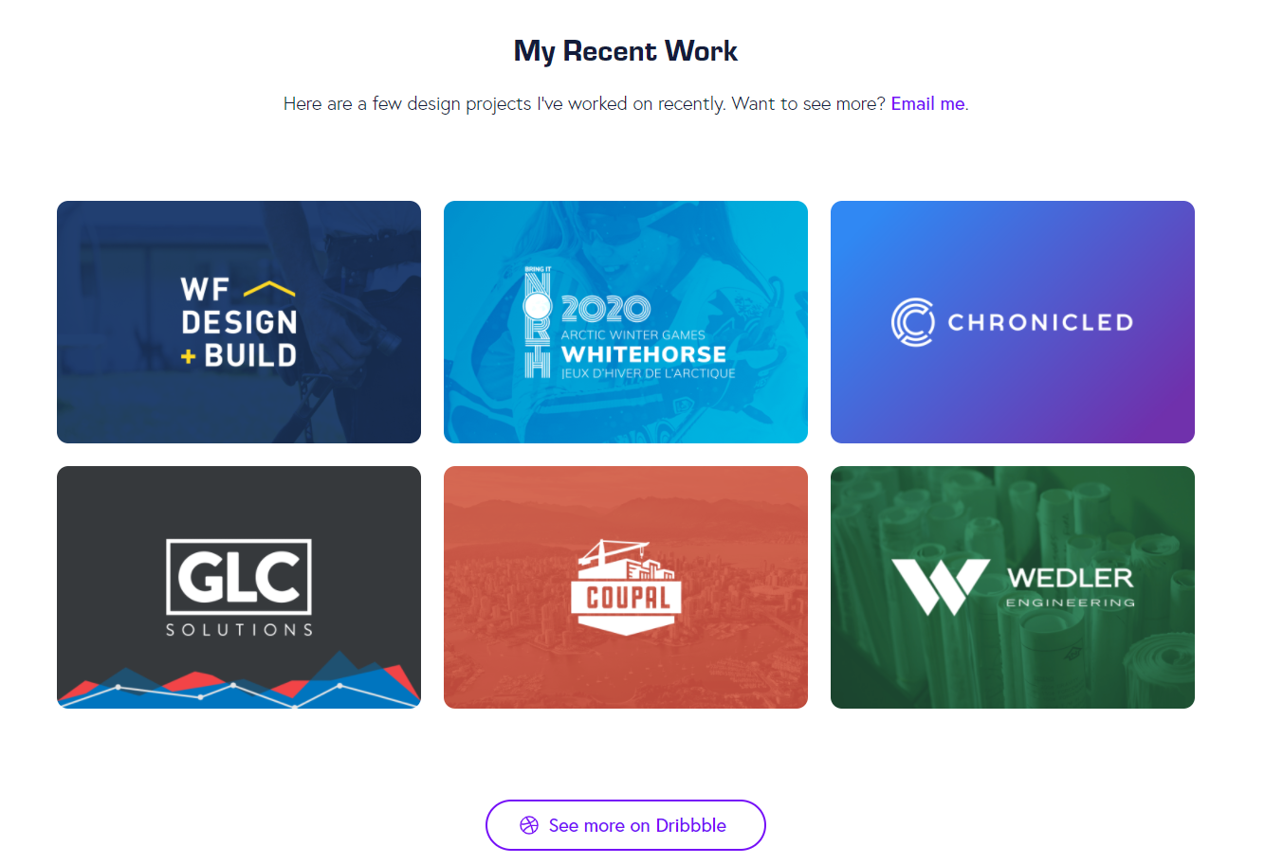

**Companies I’ve worked with:**

**TODO: PICK 6-8 companies  
TODO: WRITE descriptor  
TODO: GET logos**

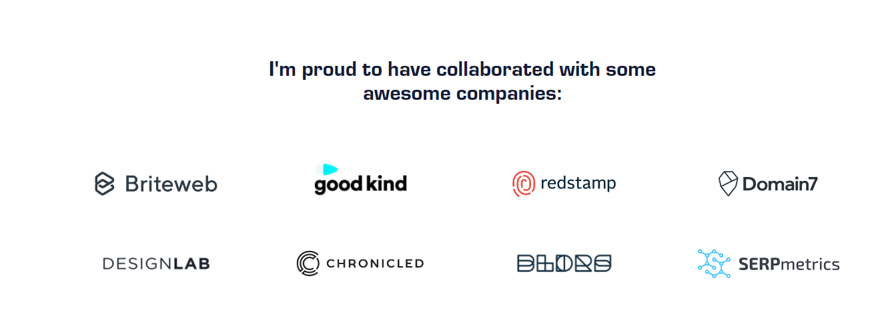

**Talks & Presentations**

**Create card layout for these…could be a carousel, show 3 (most impressive, ATD), then you can click through them.**

**MAYBE IF TIME ALLOWS HAVE A PAGE FOR THESE.**



**I also write (a few blog posts)**

**WRITE BLOG LATER….PUT PLACEHOLDER (BLOG COMING SOON) – IF THE SIT SUCKS WITHOUT IT, THEN RE-PRIORITIZE.**

**WRITE (I’m gathering my thoughts) – I’ve created/written a lot over the years, I’m pruning the tree, will, and will add old and new posts soon.**

**TODO LATER: PICK 3 Things to Write About**

* **React: When Things are Taken Out of Context**
* **Dispatch({type: post}): A Simple Intro to Managing State in React with Redux**
* **Validation Required: Learn the Basics of React Hooks by Building a Form.**

**TODO LATER: WRITE tagline for writing, similar to his projects line  
TODO LATER: DESIGN BLOG POST CARD LOOK/FEEL**

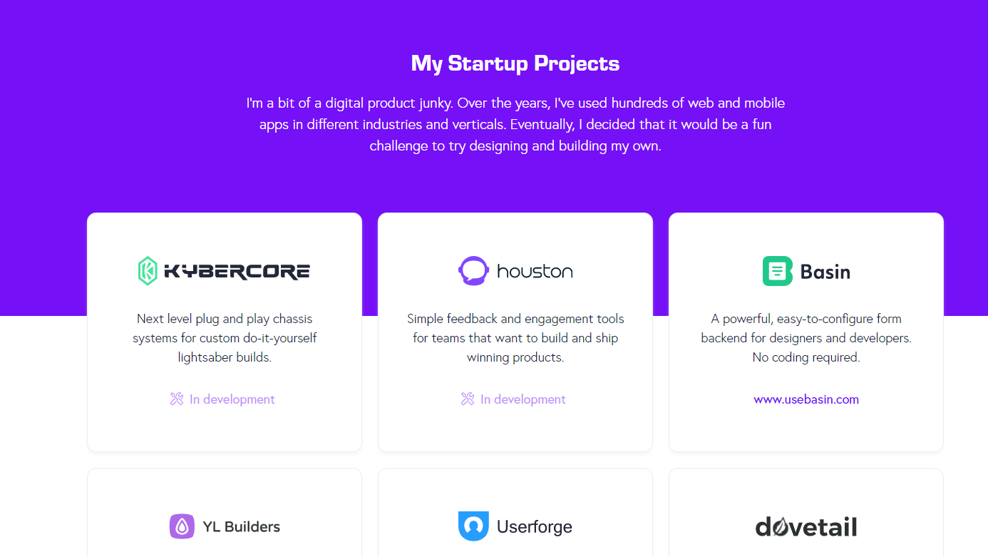

**Hire me + Custom Footer**

**TODO: WRITE THE HIRE ME  
TODO: DETERMINE Social and get links  
TODO: WRITE A LITTLE Tagline & put that site is built in next.js**

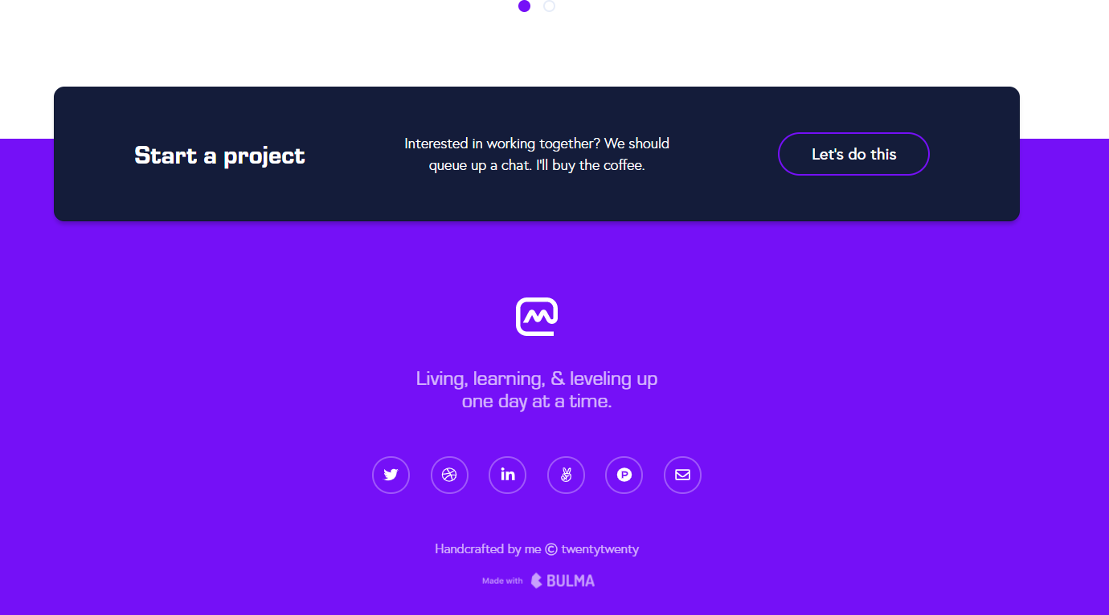

# Portfolio List Page

TODO: WRITE SOME SORT OF HEADER  
TODO: ADD SOME COOL INTERACTIVE HEADER  
TODO: EXPAND LAYOUT OF CARDS HOME SCREEN CARDS  
TODO: ADD FILTERING CAPABILITIES (WOULD BE COOL WITH LOGOS)

# Portfolio Details Page

Hero Beauty Shot  
Technology Used logo display  
Written Article describing the project and role, broken into discrete segments, with screenshots and beauty shots throughout.  
Add ability for a lightbox screenshot/description version.

BLOG PAGE  
DETEREMINE BLOG STUFF FIRST, then it’ll be similar to the portfolio page.